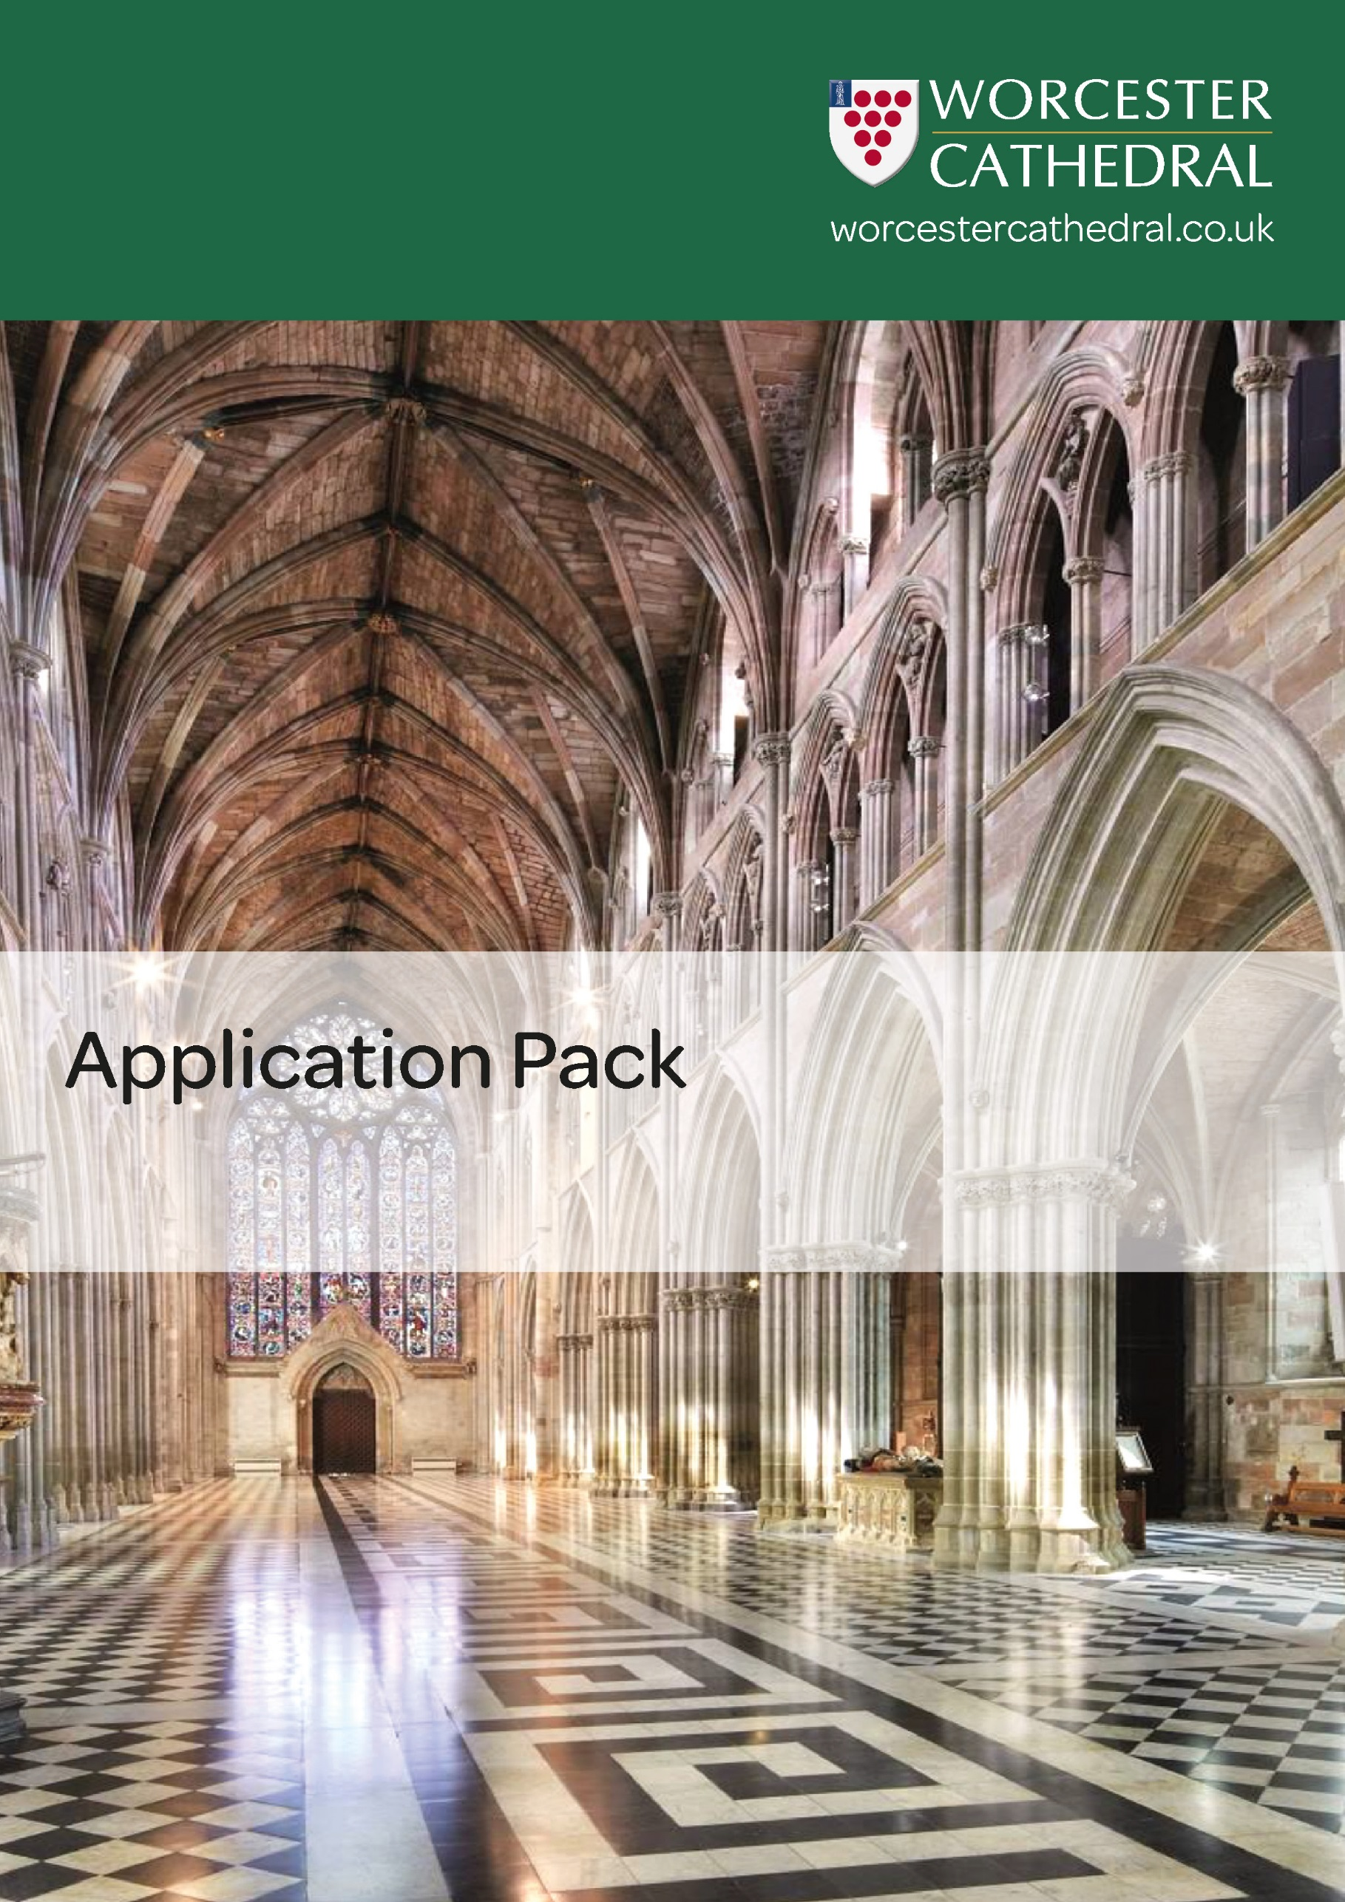

*Visitor Welcome Assistant Casual – July 2021*

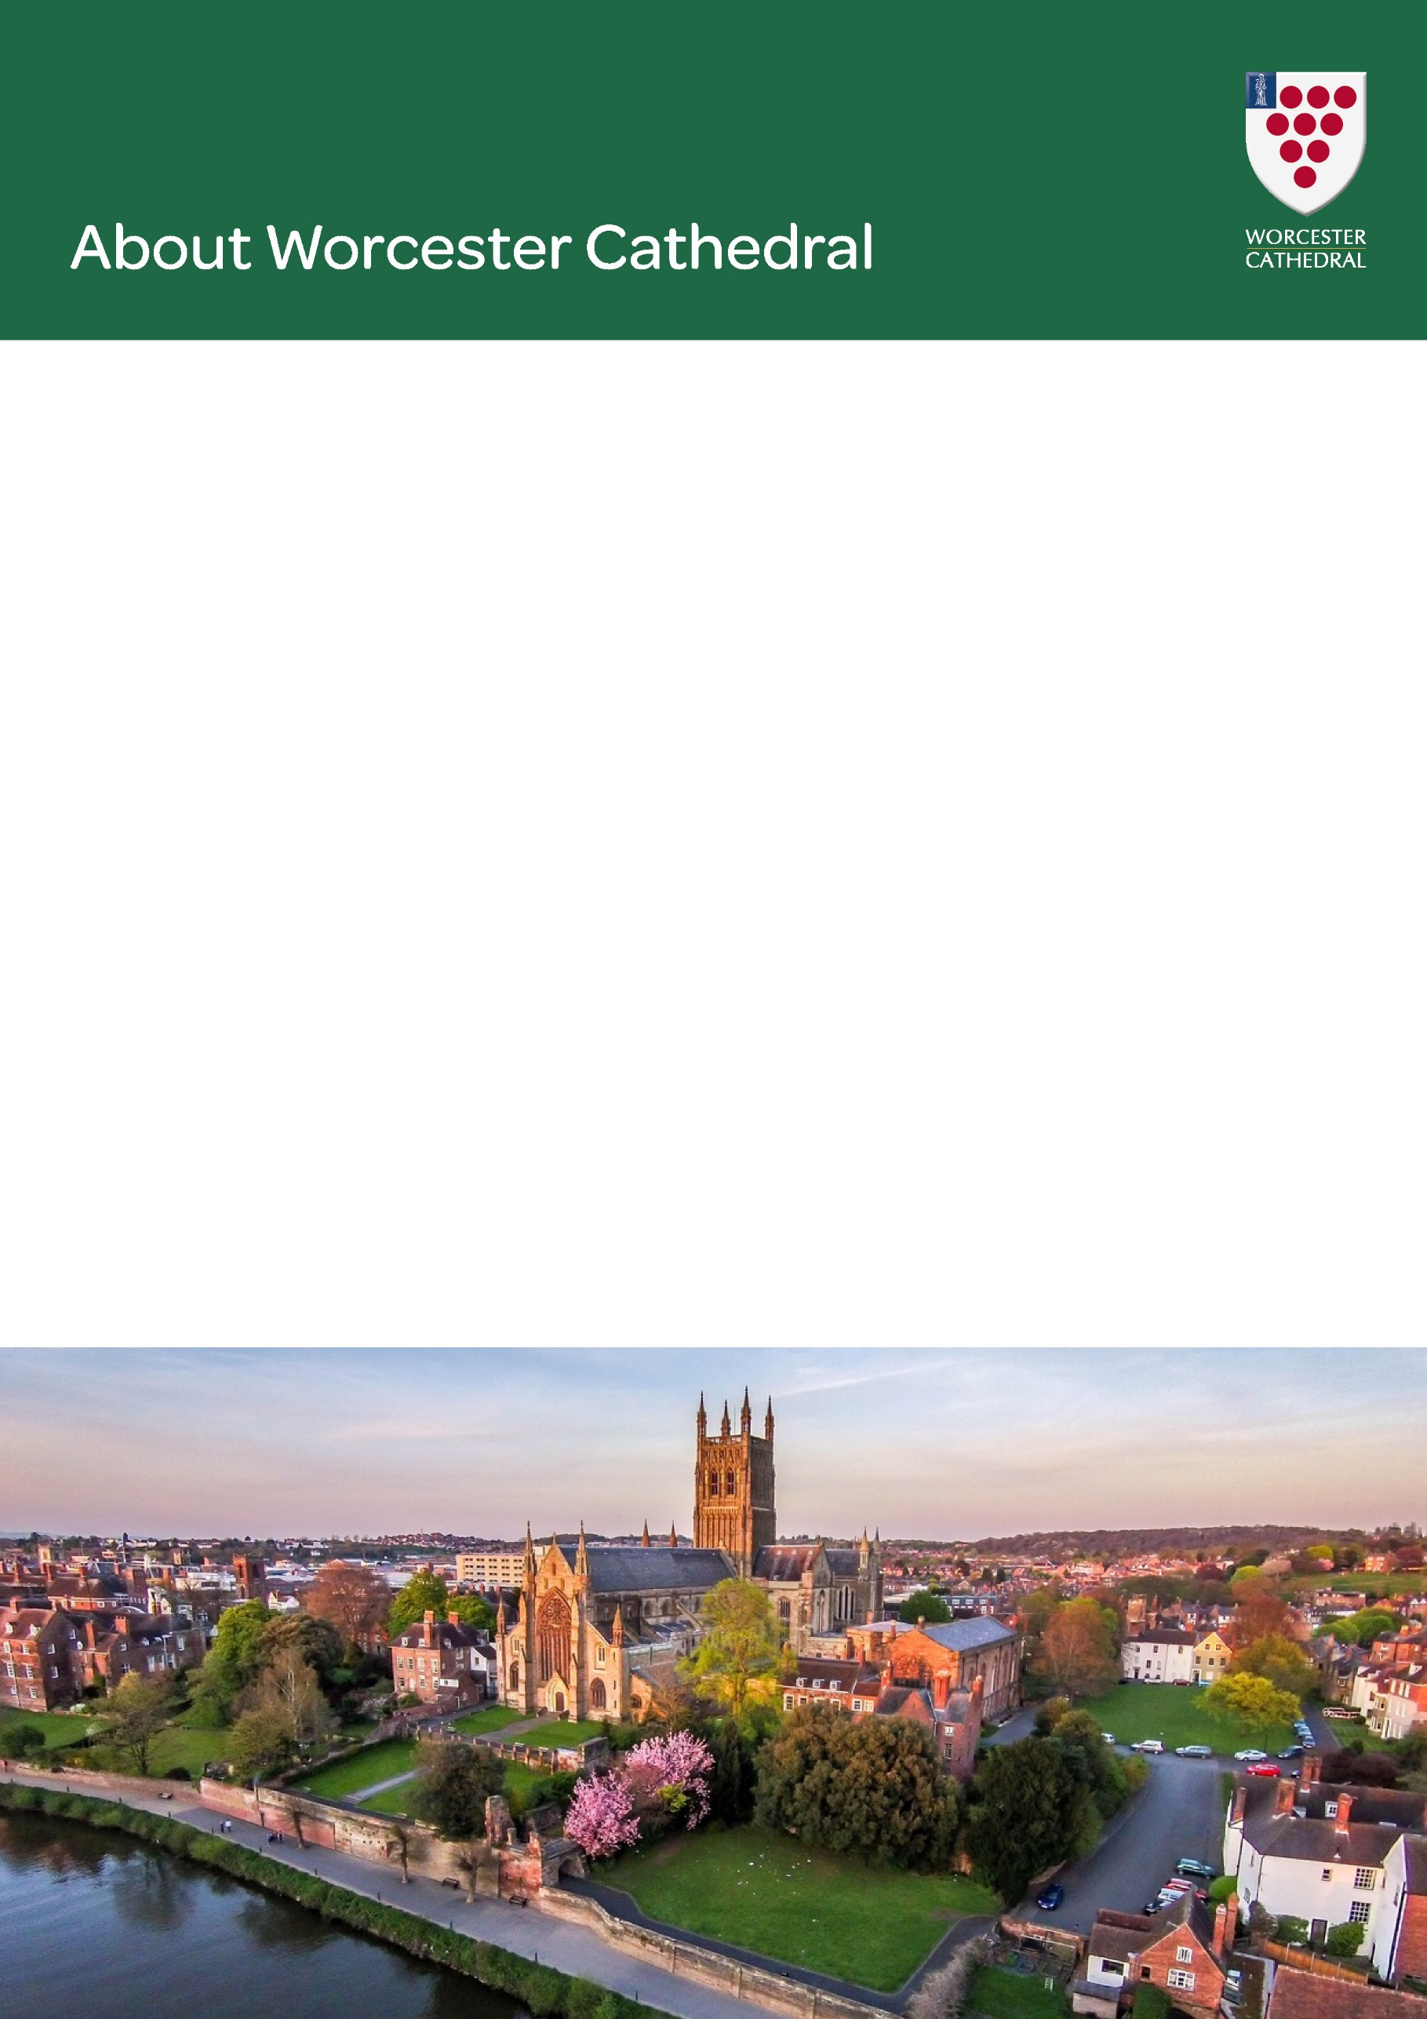

Worcester Cathedral is a magnificent sight as it rises majestically above the River Severn. Worcester has been the seat of a bishopric since the seventh century, and the Cathedral was served by monks until the Reformation. St Oswald and St Wulfstan were among the bishops. Since the eighteenth century, the Cathedral has been famous for its part in the annual Three Choirs Festival, the oldest choral festival in existence. Today, the Cathedral is the centre of a vibrant community of clergy and laypeople; offering the praises of God each day, serving the city and diocese of Worcester, and attracting visitors from all over the world.

The Cathedral community is diverse with over 100 staff and 300 volunteers. We are rightly proud of the tremendous heritage and number of partners we work with across the Cathedral to provide a warm welcome to our visitors to learn more about the history of the building, attend our many events and activities and to experience the spiritual opportunities of the Cathedral.

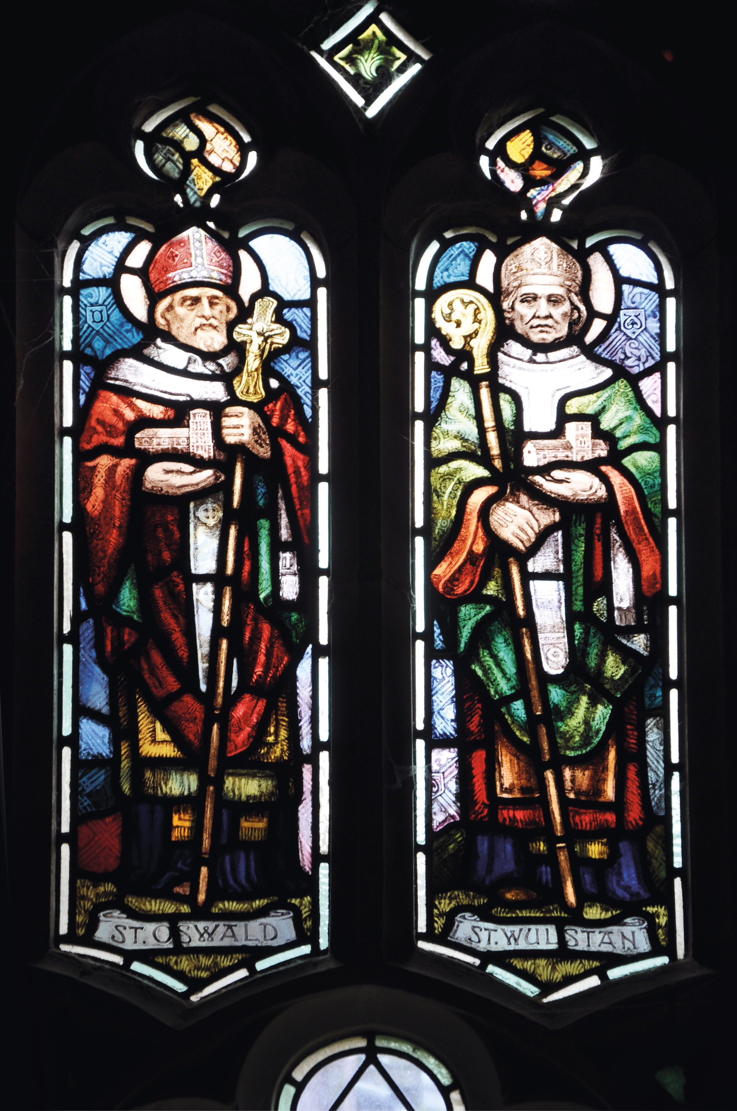

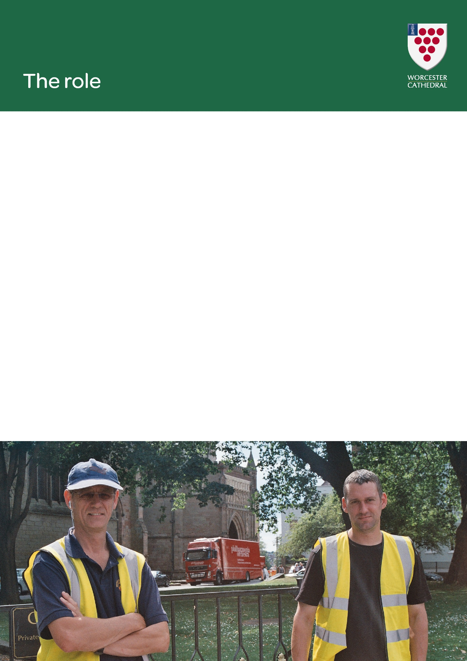

Visitor Welcome Assistant, casual

£9.00 per hour.

This is an exciting new role at Worcester Cathedral and is part of the Visitor Experience Team. Largely based in the Welcome Area, the Visitor Welcome Assistant will be on the frontline of the Cathedral’s interaction with the public; providing a world-class welcome to all Cathedral visitors and ensuring the smooth running of the day-to-day visitor experience.

To apply, please send a CV including full employment history and a maximum of one page of supporting information showing how you meet the requirements of the person specification. Please include with your application, the details of two referees, ideally from a work or educational context, that we can contact with your permission.

Applications should be sent FAO: Susan MacLeod, Visitor Experience Manager to:

[jobs@worcestercathedral.org.uk](mailto:jobs@worcestercathedral.org.uk)

Worcester Cathedral,

Chapter Office,

8 College Yard,

Worcester,

WR1 2LA

and return those to the address below by 9am on Wednesday 11th August 2021.



**Job Title:** Visitor Welcome Assistant

**Department:** Visitor Experience

**Reporting to:** Visitor Experience Manager

**Overall purpose of the post:**

To provide a world-class welcome to all Cathedral visitors;

To encourage visitors to donate on entry to the Cathedral and to meet associated financial targets;

To be a key member of the team delivering daily visitor-facing operations.

**Duties & Responsibilities:**

**Day-to-day visitor experience and welcome**

* To provide a consistently warm, professional and efficient welcome at the Cathedral’s entrance
* To regularly report to the Visitor Experience Manager on the quality of the visitor experience and make suggestions for improvement
* To act as frontline support for visitor facing volunteers, including conducting daily briefings to ensure they have a strong knowledge of the visitor offer for that day and can communicate this to the public
* To champion world class visitor experience at all times and act as a role model for exceptional service, monitoring welcoming behaviours to ensure consistently high levels of customer service are delivered
* Respond to visitor feedback in a professional and timely manner, escalating when necessary

**Supporting the delivery of visitor income generation by maximising visitor donations and sales of tours and literature, etc.**

* Offer a warm greeting to visitors and through a positive approach elicit donations from the public on entry to the Cathedral, including encouraging gift aid donations
* Working within Data Protection rules to encourage visitors to sign up to e-newsletters and future contact
* Work as part of a team to collect and record donation income and reporting on this as required
* Learn about and promote the full range of Cathedral offers, activities, facilities and services
* Raise the profile of and sell tickets for Cathedral tours, tower visits and retail items, such as photo permits

**Front-of-house set-up and presentation**

* Ensure the Welcome Area, Cathedral Floor, visitor toilets and exterior of the Cathedral are welcoming, clean and tidy at all times
* Ensuring promotional materials and signage are relevant, well stocked and in date
* Maintain excellent standards of presentation
* Being on-hand in the Cathedral to solve visitor experience issues and communicate with visitors and volunteers
* Operate tills, contactless and card machines, donor points, laptop and touch screens
* Ensure cashing up procedures are followed at the end of each shift, reviewing discrepancies, resolving or reporting them
* Support the collection of visitor feedback and data to ensure that the Cathedral has robust visitor numbers and information

**Health & safety**

* To support Cathedral operations, implementing Safeguarding practice and ensuring the safety and security of the Cathedral and its visitors by acting as the eyes and ears on the ground and reporting any concerns immediately to the appropriate colleagues
* Reporting incidents of anti-social behaviour on the Cathedral site



**Events**

* Provide some out of hours, front of house cover for events, including ticket desk duties and stewarding
* To communicate and work in conjunction with other teams to ensure events and busy days run smoothly
* Provide some support for event set up on occasion as directed by the Visitor Experience Manager

**Cathedral Precincts**

* On occasion perform duties as required in the outside space, including admitting vehicles to Cathedral grounds, assisting with disabled parking requests, and liaising with group tour drivers and those making deliveries, etc.
* Providing a warm welcome for visitors to College Yard or College Green and encouraging visits inside the building.
* Ensuring the space is presented well and free of litter, etc.
* Assisting with set up for some outdoor events

**Group visits**

* Ensure the smooth entry of groups to the Cathedral by
  + Providing a warm welcome
  + Delivering short introductory talks where appropriate
  + Liaising with volunteer guides on the day to ensure that arrangements are in place

**Personal development**

* To take part in training, and personal practical learning and development
* To represent the Department and Cathedral at appropriate events

**Other**

* The post will be primarily based in the Cathedral. The role requires the post-holder to regularly work at weekends, bank holidays and evenings. A suitable working pattern will be agreed with the Visitor Experience Manager but will include at least two weekends per month. Time off in lieu will be given or over-time may be paid with prior authorisation of the Visitor Experience Manager
* To treat everyone in a way which reflects the Cathedral’s Values
* To undertake as requested other duties as may reasonably be expected

**Health & Safety**

Under the Health and Safety at Work Act 1974, whilst at work, you must take reasonable care for your own health & safety and that of any other person who may be affected by your acts or omissions. In addition, you must co-operate with the Organisation on health & safety and not interfere with, or misuse, anything provided for your health, safety or welfare.

**Safeguarding**

All staff and volunteers are expected to demonstrate a commitment to safeguarding the welfare of all children and adults who may be vulnerable, who are involved with and/or visit the Cathedral. This will include adherence to policies and procedures, following good practice in relation to their own behaviour and conduct, and undertaking any safeguarding duties commensurate with their specific role.  All staff will be expected to successfully complete safeguarding training as part of their induction.



**REQUIREMENTS**

The post holder must be able to demonstrate:

**ESSENTIAL (E)**

**DESIRABLE (D)**

**Education/Training**

Good basic English and Maths

Qualifications in customer services, visitor experience or heritage

First Aid qualified

**E**

**D**

**D**

**Knowledge, Skills & Experience**

Experience of working in a sales or customer service or visitor facing role

Experience of delivering against performance targets

Outstanding verbal communication and interpersonal skills

First rate customer service skills

Ability to remain calm, work under pressure and manage multiple tasks

Proven ability to handle difficult situations with the public in a calm and confident manner

Ability to multi-task and prioritise without compromising on quality

Good IT skills, including the use of Microsoft packages

Ability to work with volunteers

Experience of delivering against financial targets

Previous cash handling/till reconciliation experience

Experience of working with EPOS system

Good written communication skills

Familiar with the use of tills and/or cash handling

A working knowledge of front of house ticketing systems

Knowledge of a visitor attraction operations and practises

An understanding of Safeguarding

Understanding of the history and heritage of Worcester Cathedral

**E**

**E**

**E**

**E**

**E**

**E**

**E**

**E**

**E**

**D**

**D**

**D**

**D**

**D**

**D**

**D**

**D**

**D**

**Personal qualities**

Approachable with a positive and enthusiastic attitude

Have a genuine desire to provide excellent customer service

Be a team player  
To be able to work within the ethos and mission of Worcester Cathedral as a Christian organisation

Strong attention to detail

A flexible approach to meet the ad hoc demands of the job

Able to work on own initiative without immediate supervision from manager

Motivated by and prepared to meet targets, and able to inspire others to achieve targets

**E**

**E**

**E**

**E**

**E**

**E**

**E**

**E**

*This section outlines the knowledge, skills and abilities the job holder needs in order to fulfil the requirements of*

*the post. ‘Essential’ criteria are those that the job holder absolutely must have in order to do the job. ‘Desirable’ criteria are those qualities that would be either useful, or an advantage or those which the job holder can be trained to do.*

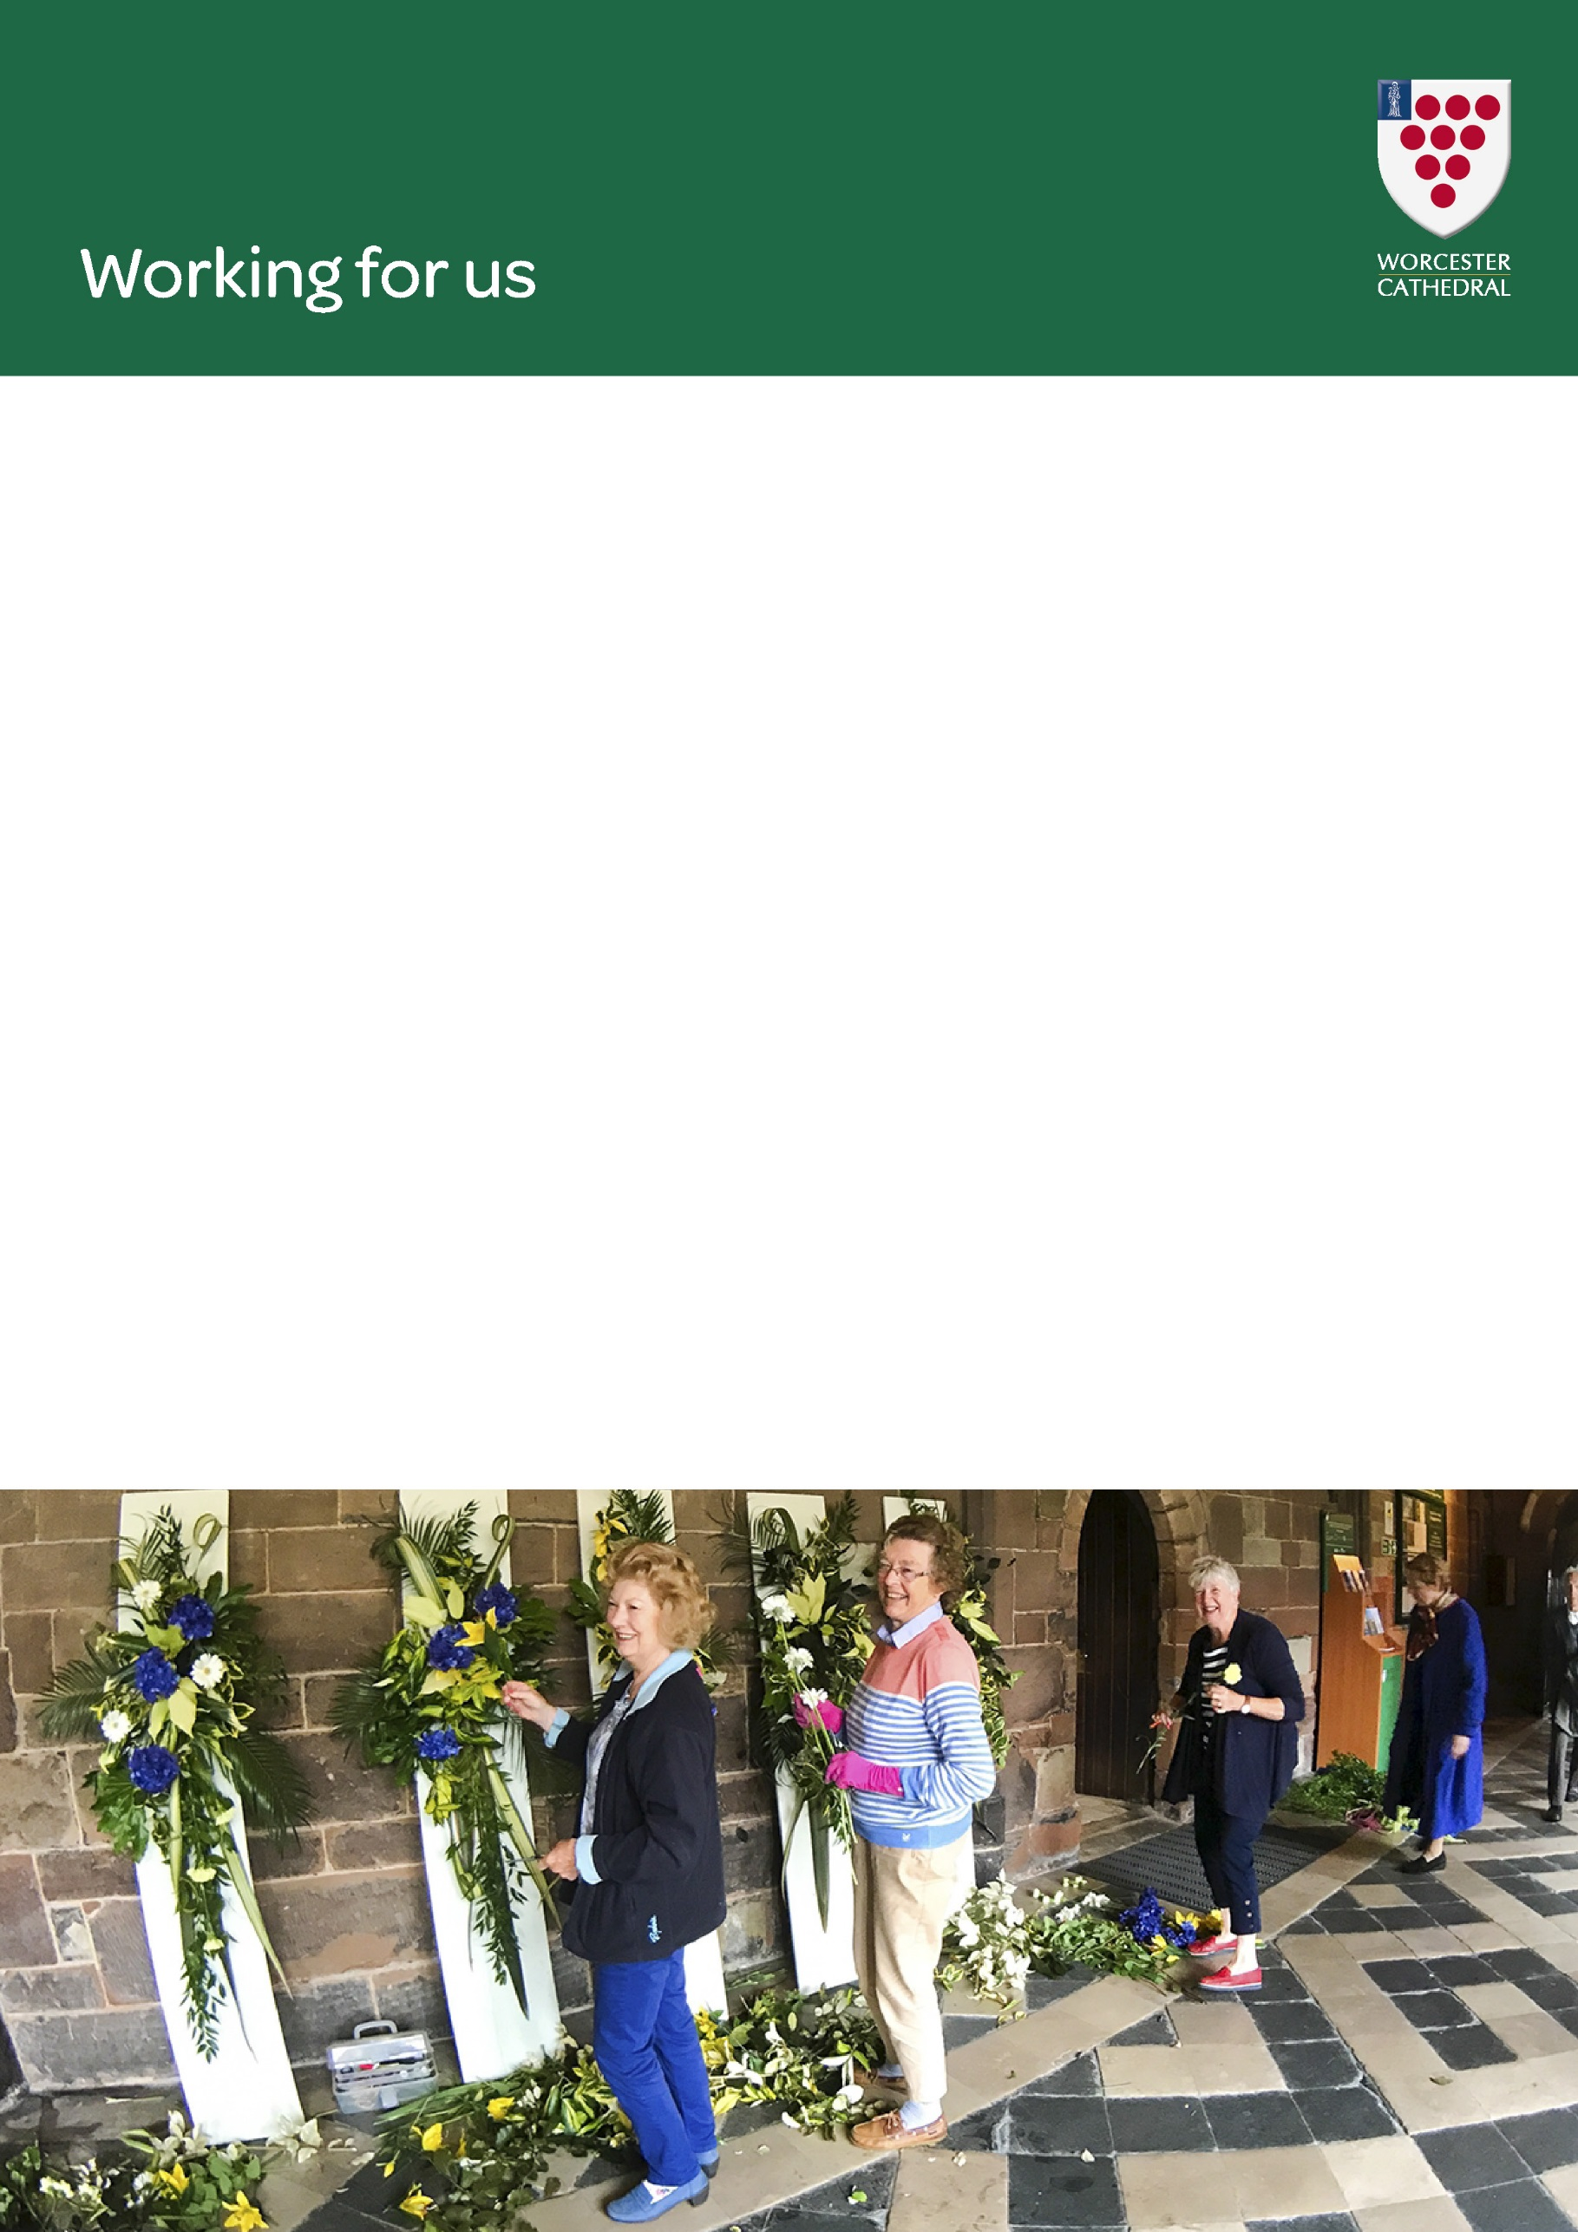

**Salary**

The salary is £9 per hour.

**Working Patterns**

The role requires the post-holder to work weekdays, weekends, bank holidays and evenings as part of a shift pattern.

**Annual Holidays**

The holiday entitlement is 25 days per annum plus 8 bank holidays and 4 discretionary Cathedral days, pro rata.

**Pension Scheme**

An employer contributory pension scheme is available for all eligible members of staff.

**Staff Discount**

All employees will receive a 10% discount on purchases in the Gift Shop and Café within the Cathedral.

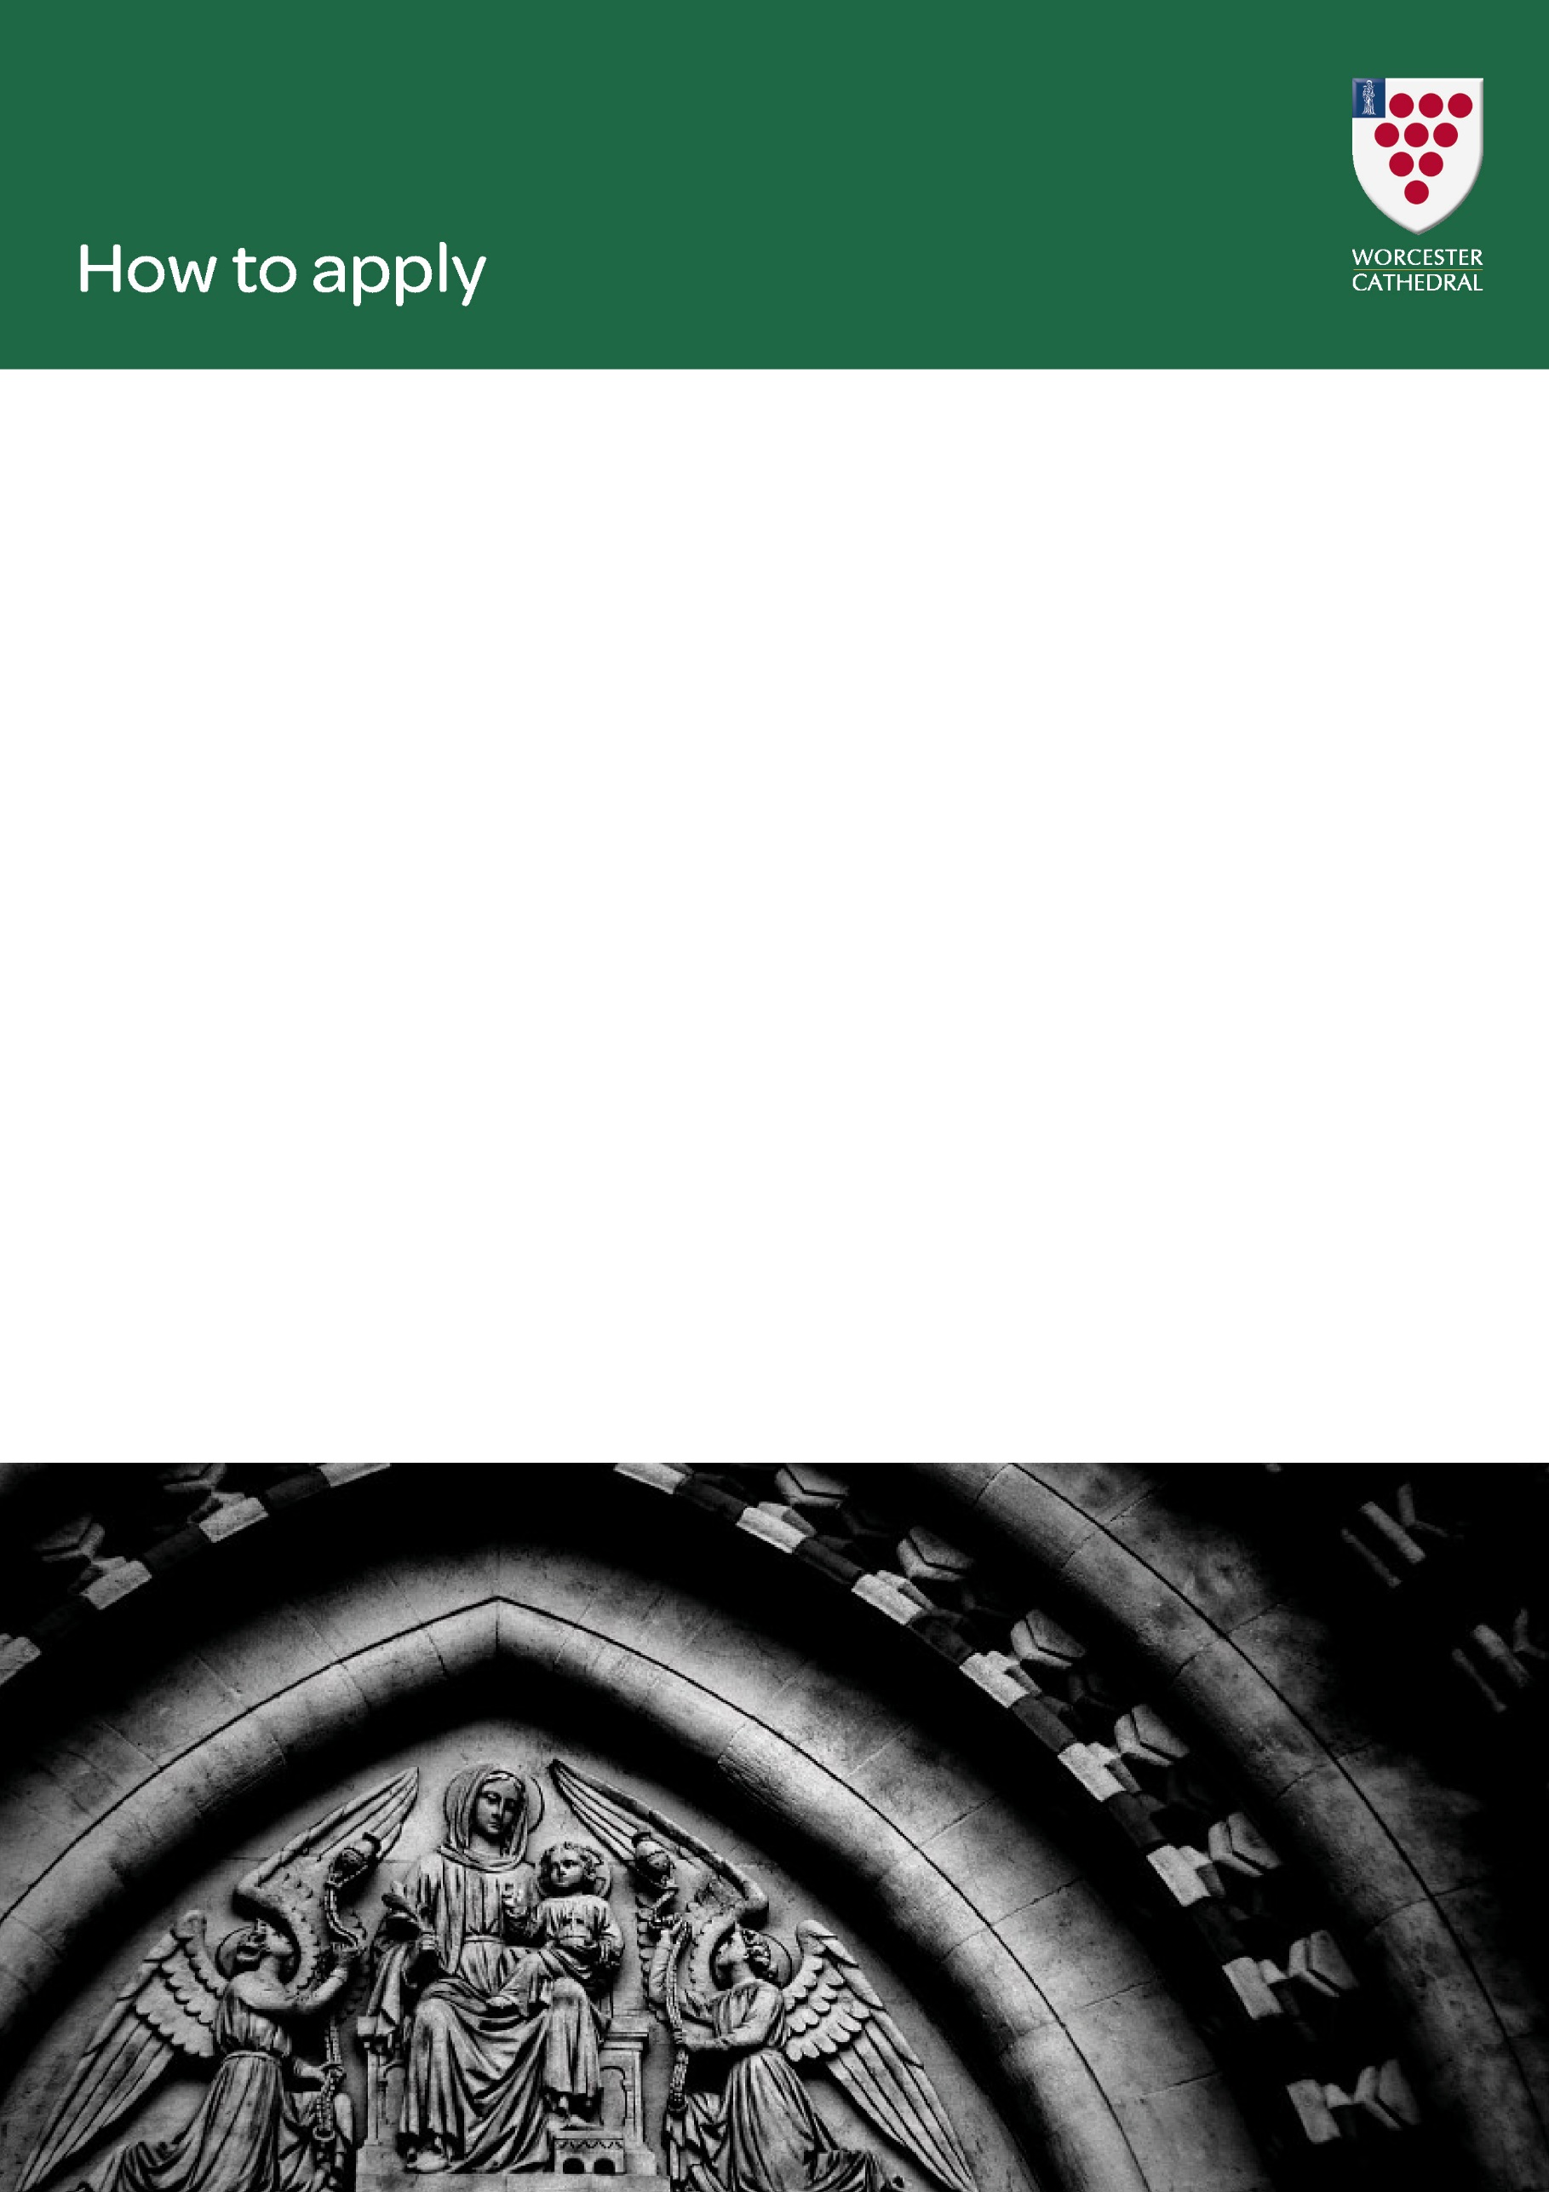

Please send a CV including full employment history and a maximum of one page of supporting information showing how you meet the requirements of the person specification FAO: Susan MacLeod, Visitor Experience Manager to:

[jobs@worcestercathedral.org.uk](mailto:jobs@worcestercathedral.org.uk)

Worcester Cathedral,

Chapter Office,

8 College Yard,

Worcester,

WR1 2LA

The closing date for the job is 9.00am on Wednesday 11th August 2021.

If you do not hear from us, within 5 days of the closing date, then you have been not been shortlisted. Due to the volume of applicants we receive, we are unfortunately unable to respond to everyone individually at this stage.