Place of Christian Worship
  - Activity Sheet – KS2
You are about to watch a video touring you around Worcester Cathedral, before you do, what do you think is the primary purpose of Worcester Cathedral?
A concert venue? A place of artistic importance? A place of Christian Worship?
Throughout the Cathedral there are many different symbols of Christian Worship. As you watch the video can you spot the following:
A cross  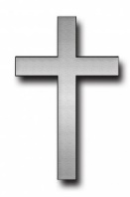 | A fish  This Photo by Unknown Author is licensed under CC BY-SA | The bible  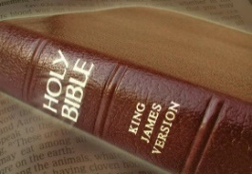  This Photo by Unknown Author is licensed under CC BY
Candles  This Photo by Unknown Author is licensed under CC BY-NC | An altar  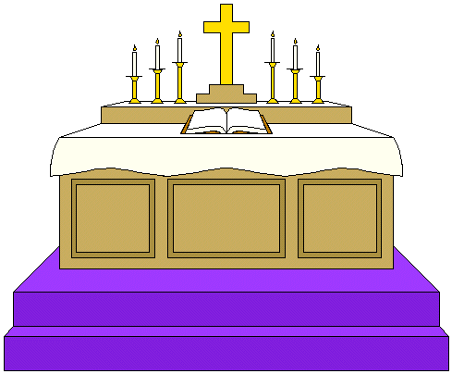  This Photo by Unknown Author is licensed under CC BY-NC-ND | Hands together in prayer

Now watch the video and see which of these you can spot https://youtu.be/84jxB9Ymxow
- Baptism
This is a picture of the font at Worcester Cathedral.
A font is where Baptism takes place. This is sometimes called Christening.
Jesus was baptised in the River Jordan.
Baptism represents being washed clean and starting anew as Christians believe happens at the beginning of your Christian life. In some churches they do it with babies, in other churches it’s adults.
The font at Worcester is very decorated. Some call it the space rocket!
This Photo by Unknown Author is licensed under CC BY-SA
Most fonts in churches are much simpler.
Have you ever been to a Baptism or Christening? Whose was it?
What happened?
If you are from a different faith background maybe there
is a similar ceremony, or naming ceremony?
Write your answer below
- The Bishop
 | Can you remember what this seat is called?  It is the Bishops throne, and its proper name is the Cathedra.  When the Bishop is leading a service as a bishop, he wears a special hat called a Mitre and carries a called a Crozier.  See the picture on the right of our Bishop, Bishop John, in his hat and with his staff. There were pictures in the video of St Wulfstan with his Mitre and Crozier.  Mitres are usually the same shape, but can be lots of different styles and colours. Have a go at designing your mitre by colouring the one below. |  | 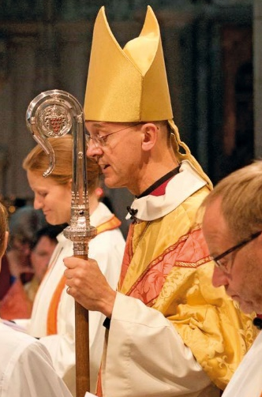
- Pilgrimage
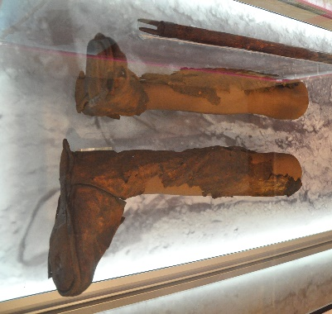 | The Worcester Pilgrim was buried at the Cathedral and found in the 1990s. The picture on the left is of his boots which are on display in the Cathedral. We believe he walked from Worcester to a famous church in southern Spain called Santiago De Compostela (Church of St James).  A pilgrimage is when you go on a journey to somewhere that is important to you. Often this is a religious site, and the act of going on the journey maybe religious. Many Muslims go on pilgrimage to Mecca.  But it does not have to be religious, it can be somewhere that is important to you. Where would you like to go on pilgrimage too?
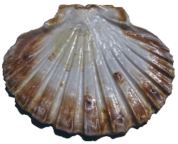 | This shell was traditionally given to Pilgrims. When students come to the cathedral on a visit they would often try and draw a shell like this one.  Have a go at drawing one in the box on the right.

